Test Cases:

Feature: Registration Form

*To Test Feilds in the registartion form*

Background:

Given I host a Registation form application

And I navigate to registation page

@tag1

Scenario Outline: To Test blank feild details

When I enter *<Username>*, *<Password>*, *<RepeatPassword>*, *<Terms>*

And I Click register button

Then Feild validation for *<Filed>* should be displayed

Examples:

| *Username* | *Password* | *RepeatPassword* | *Terms* | *Field* |

| | Valid123 | Valid123 | True | Username |

| Testuser@email.com | | Valid123 | True | Password |

| Testuser | Valid123 | | True | Repeat Password |

| Testuser | Valid123 | Valid123 | False | Terms and Conditions | --> this test is failing

Scenario Outline: To Test password feild details

When I enter *<Username>*, *<Password>*, *<RepeatPassword>*, *<Terms>*

And I Click register button

Then Alert message should contain '<AlertMessage'

Examples:

| *Username* | *Password* | *RepeatPassword* | *Terms* | *AlertMessage* |

| Testuser | 123 | 123 | True | Failed to Create |

| Testuser@email.com | validPasswordmorethan16 | validPasswordmorethan16 | True | Failed to Create |

| Testuser@email.com | 123 | validPasswordmorethan16 | True | Failed to Create |

| Testuser@email.com | validPasswordmorethan16 | 123 | True | Failed to Create |

| Testuser@email.com | valid123 | diff123 | True | Failed to Create | --> this is failing

Scenario Outline: To Test terms and conditions feild details

When I enter *<Username>*, *<Password>*, *<RepeatPassword>*, *<Terms>*

And I Click register button

Then Alert message should contain '<AlertMessage'

Examples:

| *Username* | *Password* | *RepeatPassword* | *Terms* | *AlertMessage* |

| Testuser | valid123 | valid123 | false | Failed to Create | >> failing

Scenario: To Test terms and conditions page

When I click on Terms & Privacy Link

Then It should direct me to 'terms.html' page

**Issues Identified:**

1. Form is accepted even when Terms and Conditions are not enabled – This is now fixed

1. Form is accepted even passwords doesn’t match – This now fixed in code

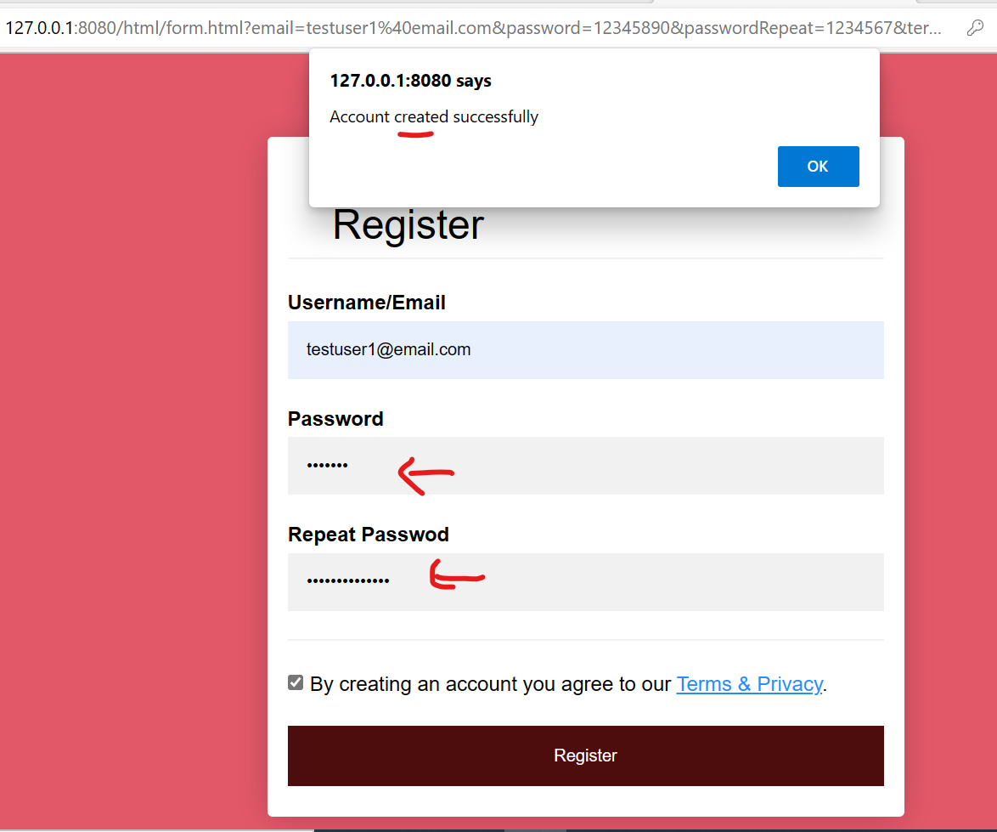

1. View password icon/button disappears when navigated out of that box and is not reappearing when clicked onto the password field.

1. Cosmetic Bug: Username spelling is incorrect within username placeholder → this is fixed on code

1. Cosmetic Bug: Repeat Password spelling is incorrect → this is fixed on code

1. Terms and conditions is not in English